The following are responses to reviewers 1 and 2. Responses to the reviewers are in blue, while edits made to the manuscript and copied here are written in red.

Reviewers' comments:
Reviewer 1: I thank the authors for their revision. I may be a bit picky but I still have few minor concerns:
I like the new fig4. However, if I understand correctly, I believe, in the last box CL and CR should be replaced by CmuL and CmuR. Or maybe in the "second stage" box RmuL should be replaced by RL ?
Yes, in the last box of the model diagram in Figure 4, C_{L} and C_{R} represent the model responses for the monocular channels. We agree with the reviewer that it would be clearer to include μ in the labels and have updated the figure accordingly.
S and Z are not there "to prevent division by 0"

Agreed, S and Z are responsible for determining the overall sensitivity of the model, but, by their nature, they also prevent division by 0. However, as this is not their primary purpose, we have removed the statement from the manuscript for each equation in which S or Z is described.
"We agree with the reviewer, the rationale for the two types of stimulus flicker could have been clarified in the introduction. …" [ … ] "Steady-State Visually Evoked Potentials offer a unique opportunity to bridge the gap between models developed from psychophysical data and neuroimaging, as responses to stimulus contrast (i.e., SSVEP amplitude) are directly associated with behavioral sensitivity to contrast (Norcia, 2015; Wade & Baker, 2025). Two common stimulus presentation protocols are used to generate SSVEPs: a sinusoidal On/Off flicker, where the stimulus alternates between a blank background (0\% contrast) and the peak contrast, and sinusoidal counterphase flicker, where the stimulus alternates in phase (i.e., the black regions become white, and the white regions become black). On/Off flicker activates different populations of on and off-cells independently once per cycle, generating frequency-following responses at the frequency of the sinusoidal modulation (1F). On/Off flicker can also generate SSVEPs at the odd and even integer harmonics (2F, 3F, 4F, etc.), which reflect nonlinear processing in the visual system (Regan, 1988). Counterphase flicker will generate two transients per cycle, resulting in SSVEPs at the even harmonics of the flicker frequency (2F, 4F, 6F, etc.). These frequency doubling responses are argued to provide a cleaner measure of nonlinear visual responses (Kim et al., 2011; Skottun, 2007). Utilizing both stimulation protocols enables a comprehensive description of linear and nonlinear visual processes, thereby generating the data necessary to evaluate psychophysical models of visual perception. "
-> So both protocols are designed to assess nonlinear responses?
Yes, both stimulation protocols can be used to assess nonlinear responses in observers' SSVEPs. However, only the On/Off stimulation protocol can generate a linear (1F) response to the stimulus, which is required to adequately probe our models. The two stimulation protocols were included in our study to generate the largest possible stimulus set for model evaluation.
Reviewer 2:
I must express dissatisfaction with the authors' reply.
0. My unnumbered comment "I'm not sure what exactly the SSVEP tells us about visual processing," was completely ignored. The authors didn't even include it with my numbered comments. (My fault, I guess, for failing to give it a number.)

Apologies for missing this comment, but this sentence read very much as rhetorical, and it was not clear how this comment was intended to improve the quality of this manuscript other than to dismiss it entirely.

Steady-state Visually Evoked Potentials are neural responses to stimuli that are presented periodically at, in our case, a relatively rapid rate. Presenting stimuli in this way elicits a steady-state response in which the visual system resonates at the stimulus rate. Typically, a steady-state response in the EEG signal appears as the sum of two sine waves, one at the stimulus oscillation frequency and one at twice that frequency - as explained by Luck in his 2014 book on event-related potential technique - but a more complex pattern can also be observed, as we have here in our study. SSVEPs offer a unique approach to quantifying non-linearities in biological systems and thus generate the necessary data to constrain models of human vision. Not only does the model need to capture the response to the stimulus at the fundamental frequency (3Hz), but also to generate the non-linearities observed in the data.

While the reviewer may not be aware of SSVEPs' role in visual perception, we do not believe an explanation falls within the purview of this manuscript. SSVEPs have a long history in vision studies, and we refer the reviewer to a review written by Norcia in 2015,
Norcia, A. M., Appelbaum, L. G., Ales, J. M., Cottereau, B. R., & Rossion, B. (2015). The steady-state visual evoked potential in vision research: A review. Journal of Vision, 15(6), 4. https://doi.org/10.1167/15.6.4
in addition to one of the original manuscripts demonstrating the value of SSVEPs in characterizing biological systems.
Regan, M. P., & Regan, D. (1988). A frequency domain technique for characterizing nonlinearities in biological systems. Journal of Theoretical Biology, 133(3), 293–317. https://doi.org/10.1016/S0022-5193(88)80323-0
1. The authors claim, "Sensitivity in our models is implicitly limited by late noise, as is assumed by all contemporary models of binocular vision." I say: citation needed. The authors continue, "It has been clear for some time now that the proposed architecture by Campbell and Green does not capture the behavioral results of binocular summation." Again, I say: citation needed. It seems this comment, which the authors concede is correct, was nonetheless effectively dismissed by them. There seems to have been no attempt to address it in the manuscript.

We conceded you were correct in describing our models as implicitly limited by late noise. We did not include citations in our previous replies, but are happy to do so now.

The inability of the original models to capture the behavioral results of binocular summation is discussed (and demonstrated) in Meese, Georgeson, and Baker (2006). However, the limitations of the Campbell and Green description of binocular summation, whereby the model can only return sqrt(2) improvement when the noise in one eye is ignored, or that the observer is able to respond selectively to the monocular pathway in monocular trials is recognized in the original Campbell and Green (1965) manuscript and by Blake, Sloane, and Fox (1981). Many models of binocular summation today assume late noise; many of these are variants of the two-stage contrast gain control model, but others exist as well and are reviewed in Blake and Wilson (2011).

The goal of this manuscript is to probe a well-established model of binocular summation, first introduced in 2006 by Meese et al., and the most recent version, developed in 2016 by Georgeson et al., that includes phase-selective and monocular channels, using novel SSVEP data. Our approach to probing this model was to begin with its simplest iteration and increase its complexity up to the 2016 model proposed by Georgeson. This allowed us to demonstrate the computational elements required in the two-stage contrast gain control model architecture to explain our effects. We are not arguing for a novel model of binocular summation, and as such, believe that explaining the original descriptions of binocular summation that are not relevant to our current model architecture is beyond the scope of this manuscript. This is why we did not address the reviewer's concern in our text.
2. I noted that the effects of condition and/or frequency on noise as well as signal should be explained. The authors replied, "The amplitude spectrum of EEG signals is pink, …which prevents a direct comparison." I'm afraid that statement is simply untrue. The amplitude spectrum may be pink but that does not prevent a direct comparison.
The sentence added to the manuscript ("There were no differences in the amplitude of the adjacent bins across experimental conditions") implies the invalid acceptance of a null hypothesis when p > .05.
The reply contains a 36-panel figure, which doesn't seem to address my concern. Again, I'm recommending separate analysis and modeling of signal and noise amplitudes. Each panel in Figs. 3, 5, 6, & 7 currently contains 6 boxes. Each of these boxes could be replaced by two boxes: one for signal, and one for noise. The vertical axis should be logarithmic. As yet, the authors seem to have ignored my request for an explanation of the noise.
Perhaps we misunderstood the reviewer's comment about using SNRs in our analysis. Our figure of 36 panels aimed to demonstrate that there were no differences in noise amplitude across our experimental conditions. As the reviewer stated in their initial review, this would make using SNR a sensible approach in our analysis. Signal-to-noise ratios do not exclude noise from our analyses; they normalize the response amplitude (the signal) relative to the noise amplitude. We calculate signal-to-noise ratios by dividing the response amplitude at the stimulation frequency or its integer harmonics by the 10 neighbouring bins (i.e. 3Hz +/- 0.5Hz). This is an important step because the SSVEP amplitude spectrum is pink; therefore, response amplitudes at lower frequencies will be higher than those at higher frequencies solely due to noise. To compare the response amplitudes across the fundamental frequency (3Hz) and its integer harmonics (6Hz, 9Hz, 12Hz, 15Hz, and 18Hz), we need to normalize them to the noise at each frequency. Our analysis demonstrates that there are no systematic differences in noise across our experimental conditions, and therefore our calculation of SNR does not confound the effects of signal we report.

We are also unclear as to what the reviewer means when they ask us to include boxplots that represent both the signal and the noise in our data, as representing signal (the response amplitude at 3Hz, for example) and noise (the average of the 10 neighbouring bins: 2.5Hz, 2.6Hz, 2.7Hz, 2.8Hz, 2.9Hz, 3.1Hz, 3.2Hz, 3.3Hz, 3.4Hz, and 3.5Hz) would only result in shifting the distribution for “signal” responses upwards for low frequency and reducing the amplitude for high frequencies (because response amplitude is dependent on the pink amplitude spectrum of SSVEPs). This would make it harder to see differences in the magnitudes of the SSVEP components, as they have different “baseline values” and are no longer normalized as they are as SNRs. Implementing a log transformation of the Y axis would not resolve the scaling issue, but it does transform the decrease in amplitude as a function of frequency from a power law to a linear one.

We have made the figure requested by the reviewer. The y-axis is logarithmic, and the signal (amplitude at the stimulation frequency and its harmonics) is drawn in red, with the noise (the average of the 10 neighbouring bins) for each signal is drawn in gray. The boxplots represent distributions across observers. Even on a log axis, we can clearly see that amplitude decreases with frequency, so the low frequencies have higher amplitude than the higher ones. The noise trails with the signal because the amplitude spectrum is pink.
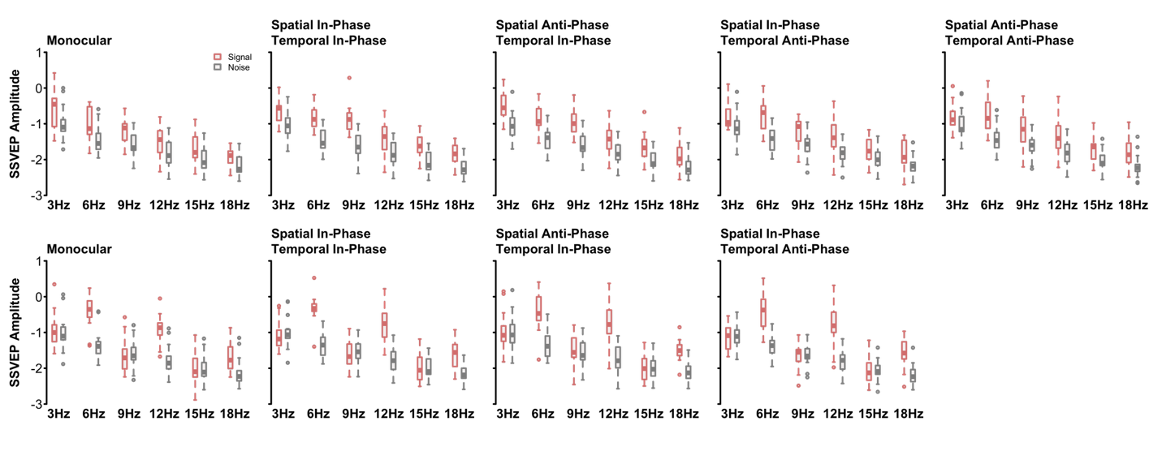
We have also made the same figure of boxplots without a log-transformed y-axis. Here we can see that the pattern is identical, but the association between amplitude and frequency follows the expected power law.
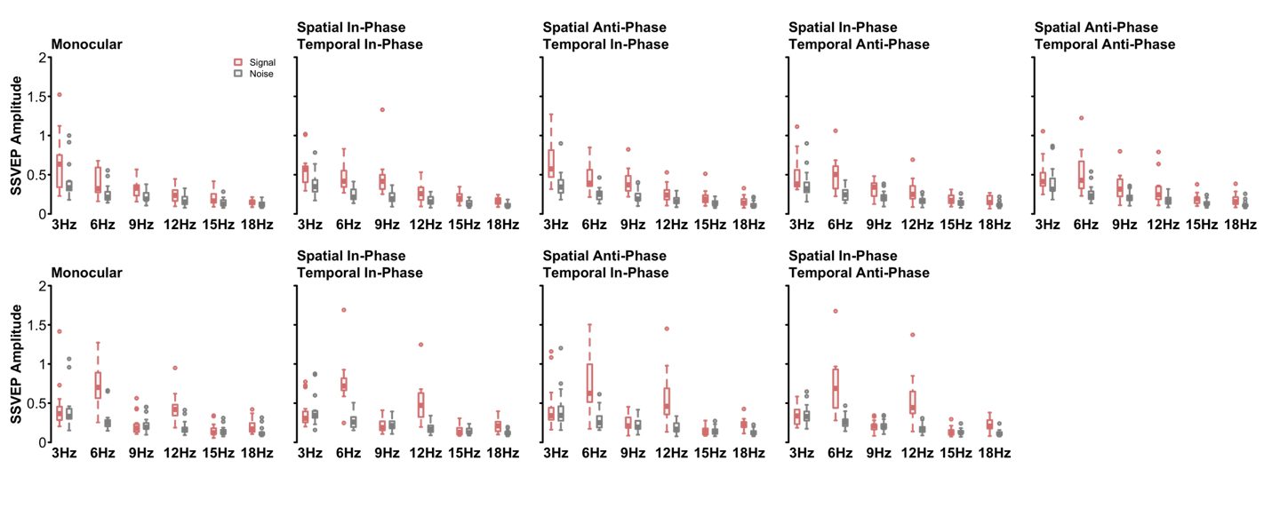
3. Accoring to Wikipedia (if there is a better reference, the authors haven't provided it) mean-squared error can be used as a surrogate for maximum likelihood when errors are normally distributed. Is that the case here? Is it even plausible?

Our AIC calculation uses the Mean Squared Error and thus assumes normality of the residuals. As the reviewer points out, because we are optimizing on the observer SNRs, the residuals will be slightly skewed. However, because we are comparing models within the same family (all are nested within our most complex model) we only care about relative differences in our AIC measures (not the actual value), and our residuals are fairly homoscedastic, we don’t believe using MSE to calculate AIC to be a significant issue.
4. There seems to have been no attempt to address it in the manuscript.
There was no need to address a question about observer pooling for nonparametric tests (which are not subject to sample-size assumptions). Explaining why observer data is aggregated into a measure of central tendency for group comparisons is elementary statistics and does not require explanation in a manuscript. As for the potential p-hacking comment, we addressed it directly with the reviewer and explained that a sample of 15 is common in SSVEP research, and it can be much larger when small effects need to be measured. The reviewer is welcome to search the literature and see that SSVEP studies have sample sizes of at least 10, but can range up to 100. In our previous publications using SSVEPs to study binocular vision we have sampled between 9 (Richard, et al., 2018) and 19 observers (note it was a total of 44, but 19 were control observers while the other were adults with amblyopia; Lygo et al., 2021). We also note that the data were collected in 2017, long before the formal analysis and modeling reported here was undertaken.
5. An equation of this form does appear (as Eqn. 5) in Legge's 1984b paper, but a) Legge himself cites Legge and Rubin (1981) for this equation and b) the symbols represent monocular contrasts and a suprathreshold matching stimulus. They do not represent "signals from the two eyes" and an improvement in contrast sensitivity.

The equation presented below the Legge 1984b citation is not a direct copy of the formula in the original manuscript, but an updated interpretation of the original sqrt(Cl²+Cr²) within the framework of the two-stage contrast gain control.

Specifically, the citation refers to the following statement: the binocular improvement in sensitivity (Legge, 1984b) is consistent with a non-linearity operating before the signals from the two eyes (c_{L}and c_{R}) are combined.

We clarified this by moving the citation so that it no longer precedes the equation.
6. ("…can improve by a factor of root 2 or more") I don't care if it is regularly used. It is meaningless. If doubling the input increases performance by a maximum factor of 1.41, then drop the 'or more'. If it increases performance by a minimum factor of 1.41, then replace 'can improve' with 'improves'. If it sometimes increases performance by less than a factor of 1.41 and sometimes increases performance by more than a factor of 1.41, then remove the meaningless sentence altogether!

We have changed this sentence to now read as
Contrast sensitivity improves by a factor of at least √2 when stimuli are presented binocularly versus monocularly.

